20) Aim: Design Turing Machine using simulator to perform subtraction of aaa-aa.

Diagram:

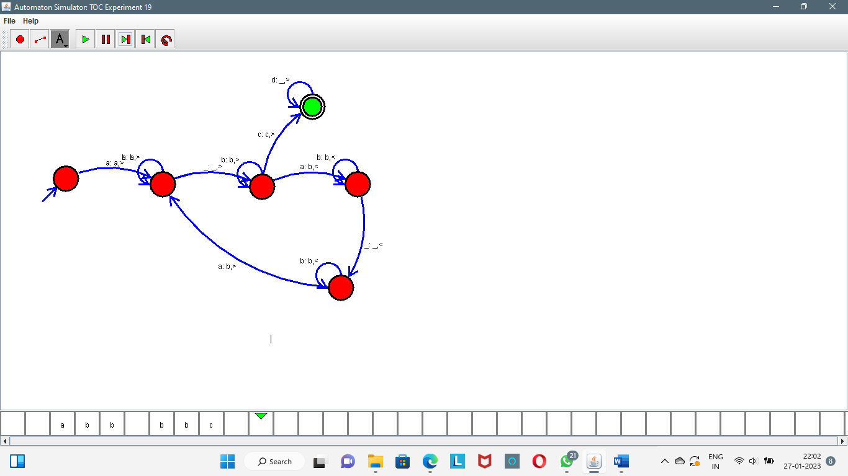

Result:

Successfully executed Turing Machine using simulator to perform subtraction of aaa-aa.